File permissions in Linux

Project description

[In this lab activity, you’ll use Linux commands to configure authorization.

Authorization is the concept of granting access to specific resources in a system. It's important because without authorization any user could access and modify all files belonging to other users or system files. This would certainly be a security risk.

In Linux, file and directory permissions are used to specify who has access to specific files and directories. You’ll explore file and directory permissions and change the ownership of a file and a directory to limit who can access them.

As a security analyst, setting appropriate access permissions is critical to protecting sensitive information and maintaining the overall security of a system.]

Check file and directory details
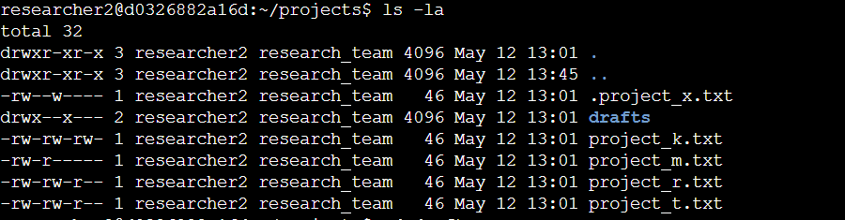
[ to check the file and directory details , i have used ls -la command in the shell. It shows the file and directory details in the projects directory]

Describe the permissions string
[a 10-character string begins each entry and indicates how the permissions on the file are set. For instance, a directory with full permissions for all owner types would be drwxrwxrwx:
- The 1st character indicates the file type. The d indicates it’s a directory. When this character is a hyphen (-), it's a regular file.
- The 2nd-4th characters indicate the read (r), write (w), and execute (x) permissions for the user. When one of these characters is a hyphen (-) instead, it indicates that this permission is not granted to the user.
- The 5th-7th characters indicate the read (r), write (w), and execute (x) permissions for the group. When one of these characters is a hyphen (-) instead, it indicates that this permission is not granted for the group.
- The 8th-10th characters indicate the read (r), write (w), and execute (x) permissions for the owner type of other. This owner type consists of all other users on the system apart from the user and the group. When one of these characters is a hyphen (-) instead, that indicates that this permission is not granted for other.
The second block of text in the expanded directory listing is the user who owns the file. The third block of text is the group owner of the file.
.]

Change file permissions
[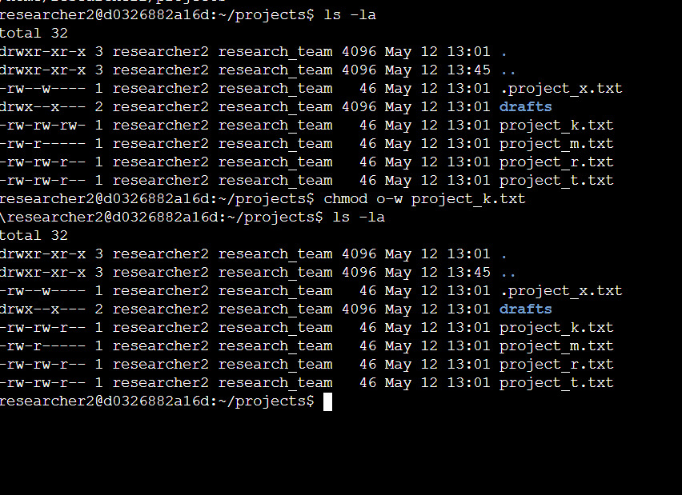in the projects directory the project_k.txt has incorrect permissions , this project_k.txt other mustn’t have write permissions to change file permission i used chmod o-w project_k.txt command to remove the write permission to the project_k.txt]

Change file permissions on a hidden file
[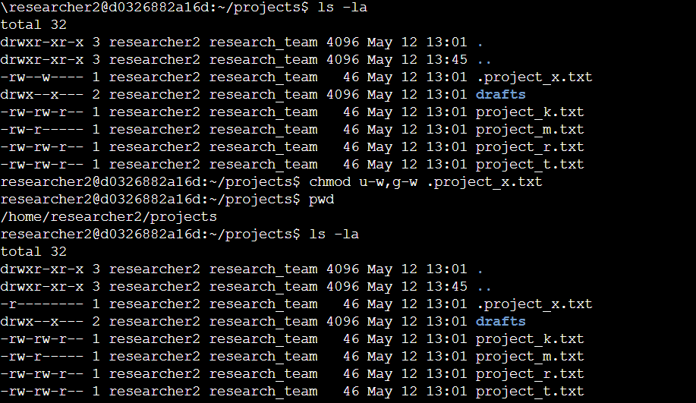the hidden file .project_x.txt mustn’t contain write permissions to anyone , but the user and group consists of write access permission to change this i used the command “chmod u-w,g-w .project_x.txt”.]

Change directory permissions
[.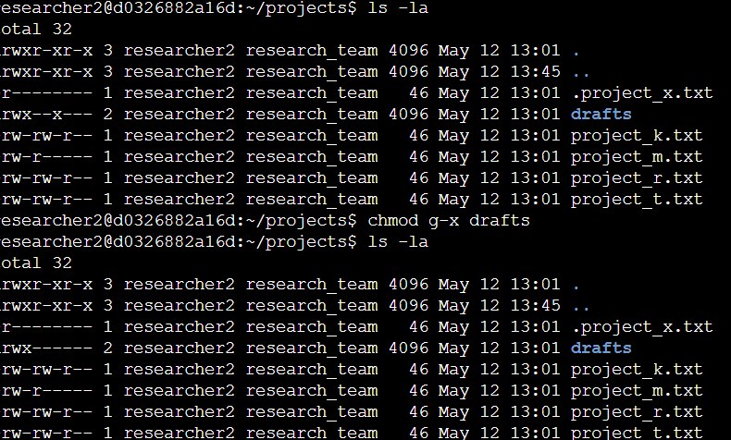 the drafts directory mustn’t contains execute permission to the group , to change this i used “chmod g-x drafts” command to remove execute command to group in the drafts directory]

Summary
[i learned to Check permissions for files in a directory, to Check for incorrect file permissions , change permissions as needed and Remove unauthorized access to a directory
.]

